**Gujarat Technological University **

**Chandkheda, Ahmedabad**

**Affiliated**

**Vishwakarma Government Engineering College**

A

Project Report

On

**Automatic Time Table Generator**

Under Subject of

**Design Engineering-IIA**

B.E., Semester V

Computer Branch

Submitted by:

Sr. No. Name Enrollment No.

1 Ghelani Kashyap 180170107032

2 Khokhar Sahil 180170107047

3 Kothari Tirthak 180170107049

4 Dudhat Krushit 180170107029

Team ID:248736

Prof Kaushik K Rana Prof Mansukh T Savaliya

**Faculty Guide Head of the Department**

Academic year

2020-2021

**CANDIDATE’S DECLARATION**

We have finished our project report entitled”​**Automatic Time Table Generator**” and submitted to our respective guide. We are in 5​th semester and we have tried to give our best. We have done our work honestly and in a good way.

|  |  |  |
| --- | --- | --- |
|  | : ​Ghelani Kashyap |  |
| First Candidate’s Name |  |
| Branch | : ​**CE** |  |
| Enrollment No. | : ​​**180170107032** |  |
|  |  |  |
| Second Candidate’s Name :​**Khokhar Sahil** | |  |
| Branch | : ​**CE** |  |
| Enrollment No. | : ​​​**180170107047** |  |
|  |  |  |
| Third Candidate’s Name | **: Dudhat Krushit** |  |
| Branch | **:CE** |  |
| Enrollment No. | **:180170107029** |  |
|  |  |  |
| Fourth Candidate’s Name | **:Kothari Tirthak** |  |
| Branch | : **CE** |  |
| Enrollment No. | : **180170107049** |  |

Submitted to: Vishwakarma Government Engineering College, Ahmedabad.

Affiliated to: Gujarat technological university.

**ACKNOWLEDGEMENT**

We would like to extend our heartily thanks with a deep sense of gratitude and respect to all those who has provided us immense help and guidance during our project.

We would like to express our sincere thanks to our internal guide **(Prof. Kaushik K Rana**) for providing a vision about the system and for giving us an opportunity to undertake such a great challenging and innovative work. We are grateful for the guidance, encouragement, understanding and insightful support given in the development process.

We would like to extend my gratitude to Head of Computer Engineering Department, Vishwakarma Government college of Engineering, Ahmedabad, for his continuous encouragement and motivation.

Last but not the least we would like to mention here that we are greatly indebted to each and everybody who has been associated with our project at any stage but whose name does not find a place in this acknowledgement.

Yours Sincerely,

​​

Ghelani Kashyap(180170107032)

Dudhat Krushit(180170107029)

Kothari Tirthak(180170107049)

Khokhar Sahil(180170107047)

**Table of contents**

**Sr. No. Title Page No.**

1. Title page 1

2. Table of contents 4

3. Abstract 5

4. Introduction of Project 6-7

5. **Canvas:**

1. Empathy Canvas 8-9
2. A.E.I.O.U Canvas 10
3. Mind map Canvas 11
4. Ideation canvas 12
5. Product development Canvas 13
6. Learnings New Matrix(LNM) 14
7. Conclusion 15

**Abstract**

Nowadays, technology has become an integral part of our life. Everything we do is somewhat linked with technology. It not only makes our job simpler but also saves our time. In schools and colleges, institute needs to prepare time table for their students so that continuity is maintained. But preparing it manually is quite tedious task. So here also technology can be utilized to prepare the time table. Automatic Time Table Generator is an application which schedules entire table on its own. We just have to provide some input such as time duration, no of subject, etc. This application generates time table in very short time. Institutes can used it to schedule their time table.

**Introduction to Project**

Most colleges have a number of different courses and each course has a number of subjects. Now there are limited faculties, each faculty teaching more than one subjects. So now the time table is needed to be scheduled in such a way that their timings do not overlap and the time table schedule makes best use of all faculty subject demands. We use a genetic algorithm for this purpose. Genetic Algorithm  is a search heuristic that reflects the process of natural selection where the fittest individuals are selected for reproduction in order to produce offspring of the next generation.

Automatic Time Table Generator has been designed to improve the system of generating timetable for classes and giving a lot more flexibility to both the staff and the students. Since generation of a time table is a tedious process and there are various permutations and combinations required to get the correct class-wise flow, the timetable software aims to automate this process. The timetable software tracks all subjects and classes and offers various combinations to the user to choose from. The timetable software is a user-friendly automated process that gives flexibility and a combination of options.

One can effortlessly create timetable for different years/semesters and sections. Based on the start and end time of your school /colleges you can place duration of each class and system produces the timetable slots according to this rules specified. It also offers the flexibility to do manual intervention including overriding some of the rules you have defined earlier in the system .You can edit, review and finalize and regulate it to meet the practical needs. After the creating a timetable you can allocate teacher/ professor and subject to the selected time slot as per your requirements.

* Features of Automatic Time Table Generator:
* A teacher can easily fetch any detail related to subjects, with just a few clicks
* Using this app, if student want to take leave, than he/she can request it to the professor and professor can give his response.
* The head of the department or principal will monitor the activities such as attendance of students, progress of the syllabus and can guide the faculty if required.
* The students as well as faculty will get reminder on their phone regarding lecture, so there is no need to remember the time table.
* If the syllabus is lengthy and extra lectures are required than professor can also schedule these lectures using the application.

**Empathy canvas**

To define any user’s centric problem we need to know the user properly. That was what this canvas was all about.

We thought about so many people but wanted to go for some people that mostly remain untouched by technology but are larger in number.

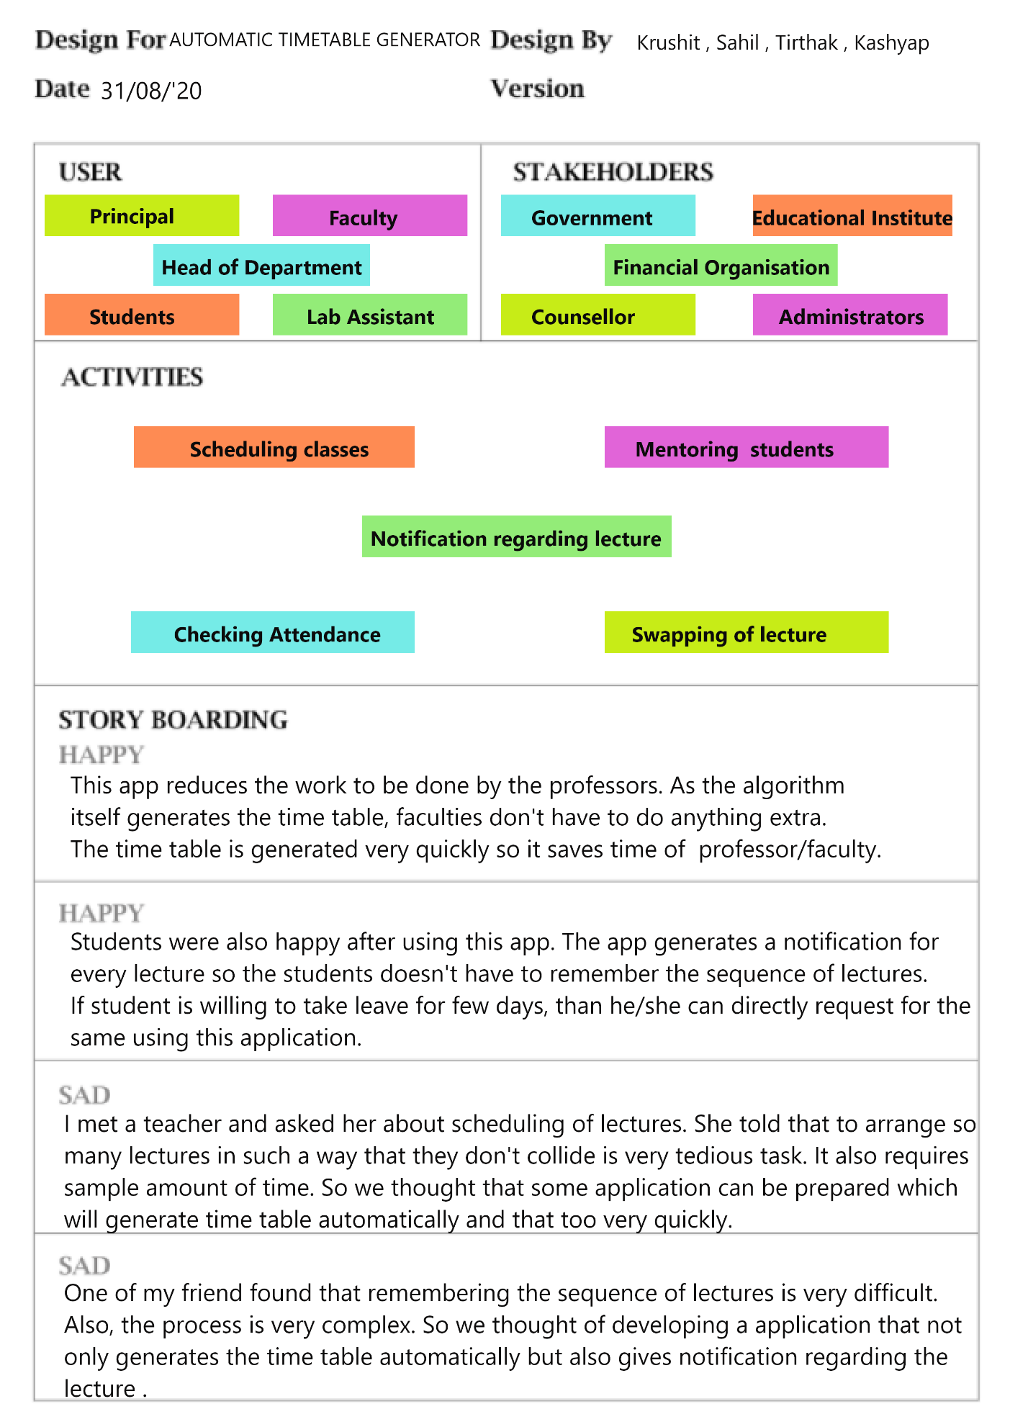

**AEIOU Canvas**

**AEIOU** stands for 5 elements to be coded: Activity, Environment, Interaction, Object, and User.

Activities: it is goal, directed sets of actions, paths towards things people want to accomplish.

Environments: It include the entire arena where activities take place.

Interaction: it is between a person and someone or something else; they are the building blocks of activities.

Objects: They are building blocks of the environment, key elements sometimes put to complex or unintended uses

Users: They are the people whose behaviour, preferences, and needs are being observed

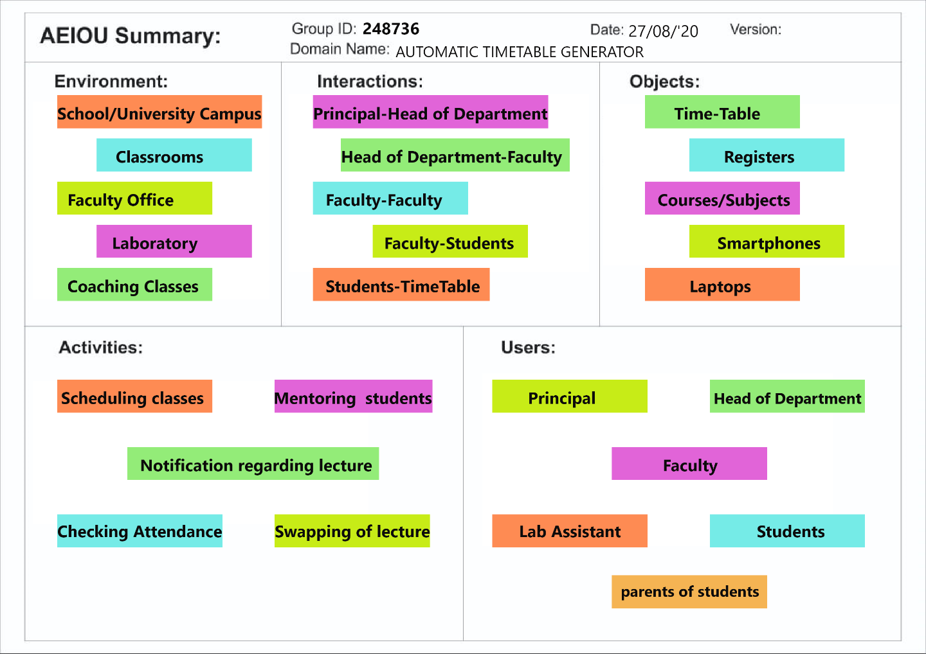

**Mind Map**

This canvas is summarization canvas for all the other canvases we used during the designing process. We included users in our canvas users are the persons who use this application or who are connected with this sector. Also we include problems and solutions in this canvas. This canvas is very useful to develop website.

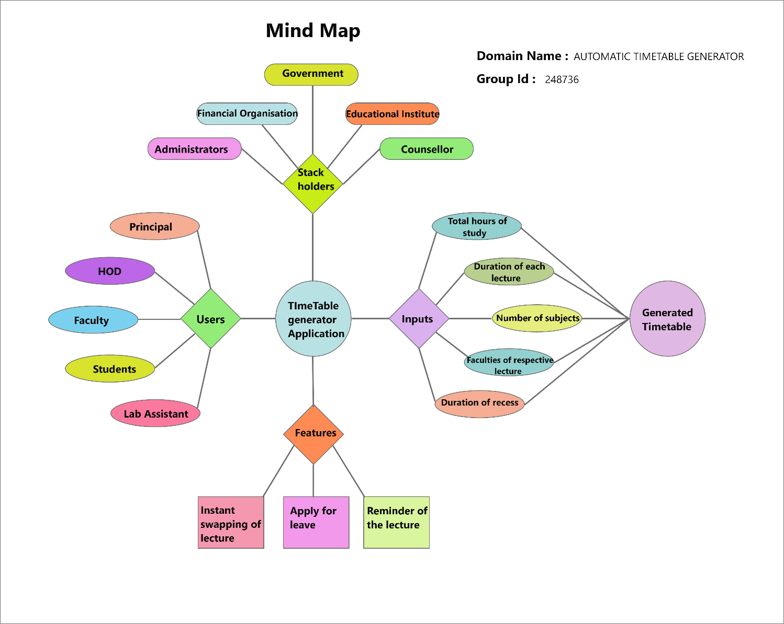

**Ideation Canvas**

In ideation canvas we started problems faced by the people. This includes all the users that can access our website. There are various people who are connected with our project like technician, residential people, employees, students etc. Then we listed out that what activity every segment of people does. Then we thought about situation/context/location and finally found out possible solutions.

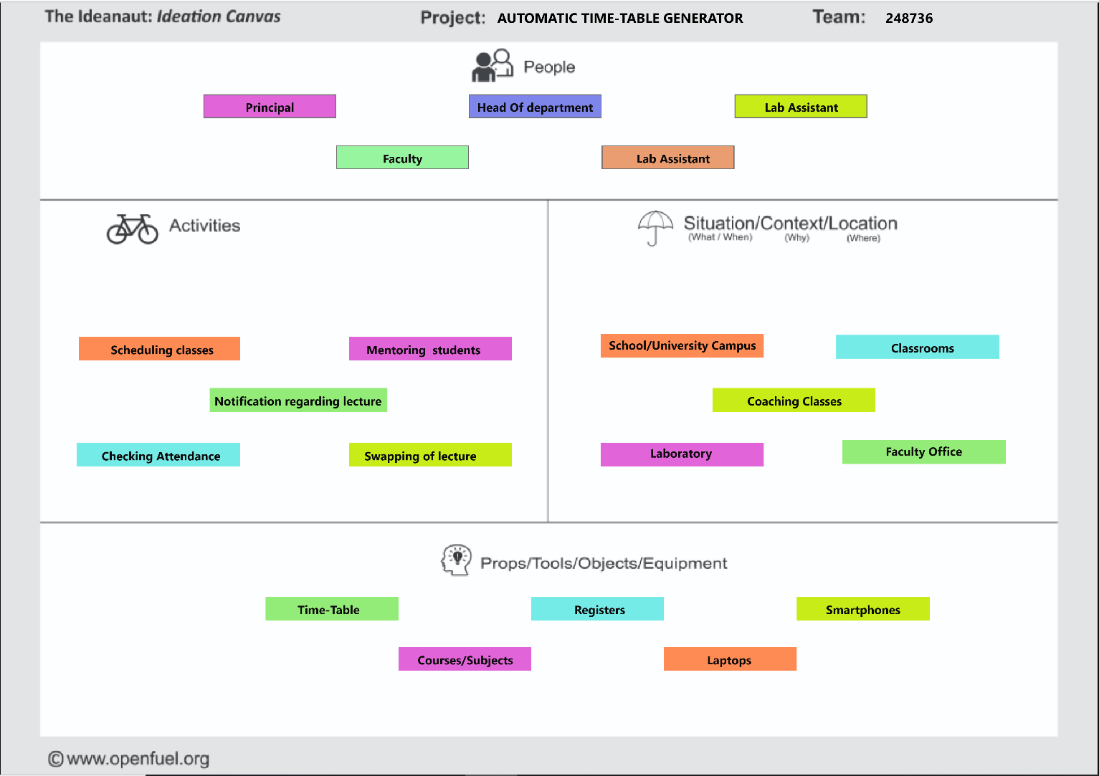

.

**Product Development Canvas**

In this canvas we mentioned purpose of our product, functions, features and products experience.

For this purpose, we defined some functions that our product must do. There should be some extra features of the product which attract the people. They are mentioned below.

Apart from this, other components which are required for our product are also mentioned.

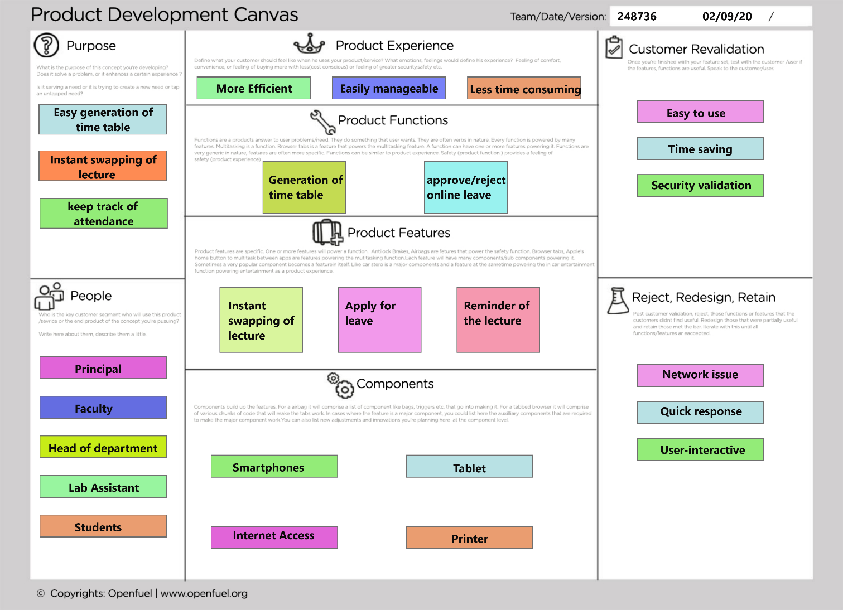

LNM (Learnings New Matrix)

The purpose of LNM is to identify the requirements of learning among the team members. While a new product/process is under development based on a unique idea (to reduce the level of difficulty faced by a user), the team members need to learn and explore a lot of new skills and documents, methods and guidelines.

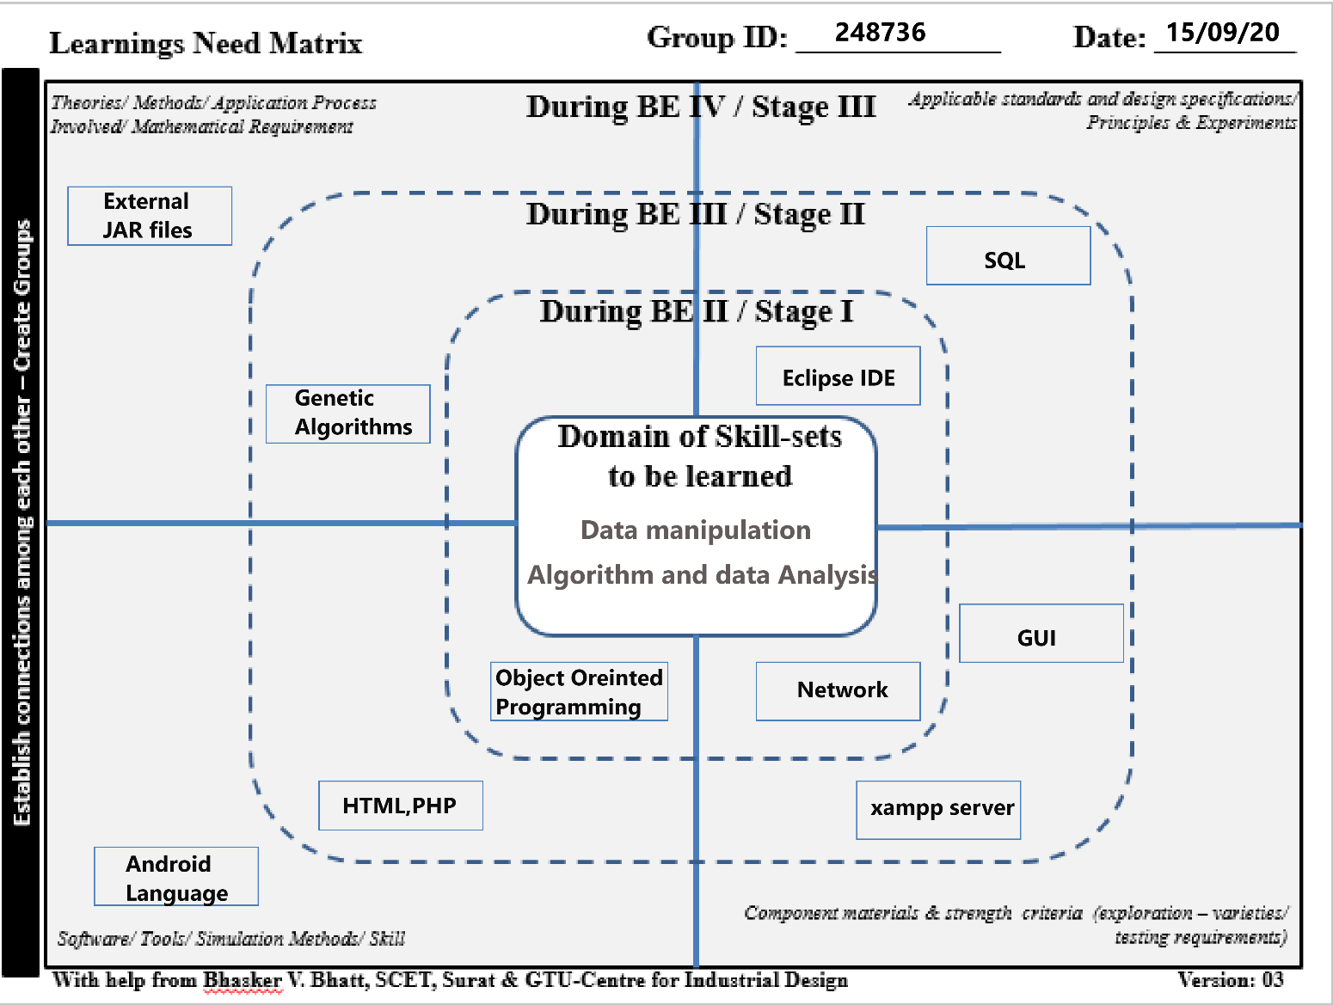

**Conclusion**

This project is specially developed for the overcome the problems faced by the teachers and faculties. Scheduling a time table requires lots of permutation and combination. Also it requires large amount of time. So using this application scheduling the time table will become easy and also fast. Apart from scheduling, some additional features are also added which will enhance its capability. The application is user-friendly and very simple to use.